Wireshark Packet Analysis

1. Introduction
Packet analysis is a fundamental cybersecurity technique used to monitor, inspect, and troubleshoot network communications. This task involved capturing and analyzing network traffic using Wireshark to understand how devices communicate over a network and to identify common protocols and potential anomalies.
2. Objectives
- Capture and analyze DNS, TCP, and HTTP traffic.
- Examine packet structure and protocol fields.
- Understand the TCP three-way handshake process.
- Identify any unusual or malformed packets.
- Document findings with supporting evidence.

3. Tools Used
- Wireshark
- Windows 11
- Google Chrome
- Active Wi-Fi connection

4. Environment Setup
Component | Details
Operating System | Windows 11
Network Interface | Wi-Fi
Packet Analyzer | Wireshark
Test Websites | www.linkedin.com, http://neverssl.com

5. Methodology
- Installed and configured Wireshark with Npcap.
- Selected the active Wi-Fi interface for packet capture.
- Started packet capture and generated network traffic by visiting selected websites.
- Applied protocol filters to isolate DNS, TCP, and HTTP packets.
- Examined packet details, headers, ports, IP addresses, and protocol flags.
- Saved screenshots and the packet capture file for analysis.

6. Analysis
6.1 DNS Traffic Analysis
A DNS query was generated when accessing www.linkedin.com.
- Source IP: 192.168.29.151
- Destination IP: 192.168.29.1
- Destination Port: 53
- Protocol: DNS

The DNS response contained CNAME records associated with LinkedIn and Cloudflare services, demonstrating how domain names are resolved before communication begins.

Observations:
- DNS uses port 53.
- The router acted as the local DNS server.
- Multiple CNAME records were observed for content delivery and load balancing.
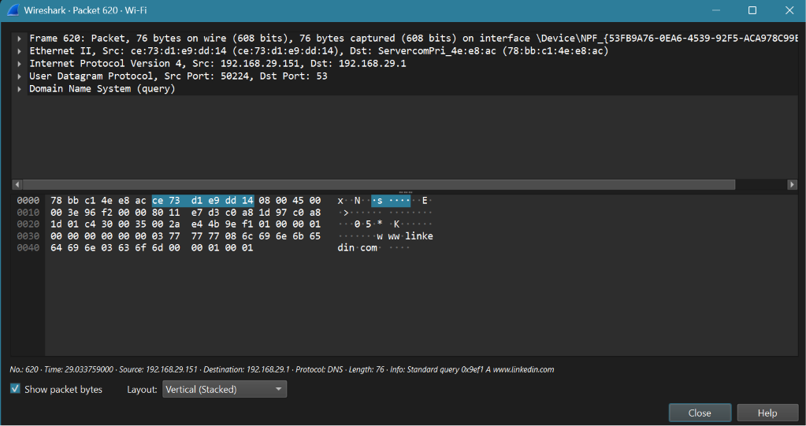

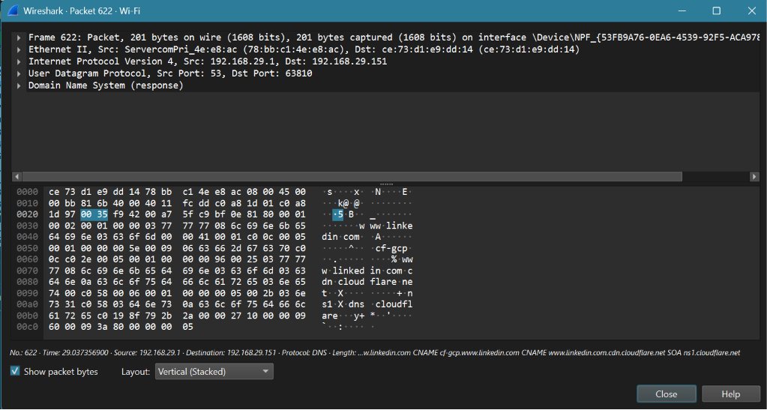

6.2 TCP Three-Way Handshake Analysis
A TCP connection was established between the client device and a remote server over HTTPS (port 443).
The following packets were observed:
- SYN
- SYN, ACK
- ACK

Source | Destination | Port | Flag
192.168.29.151 | 13.89.179.10 | 443 | SYN
13.89.179.10 | 192.168.29.151 | 58297 | SYN, ACK
192.168.29.151 | 13.89.179.10 | 443 | ACK

The successful completion of the three-way handshake established a reliable connection before data transmission.

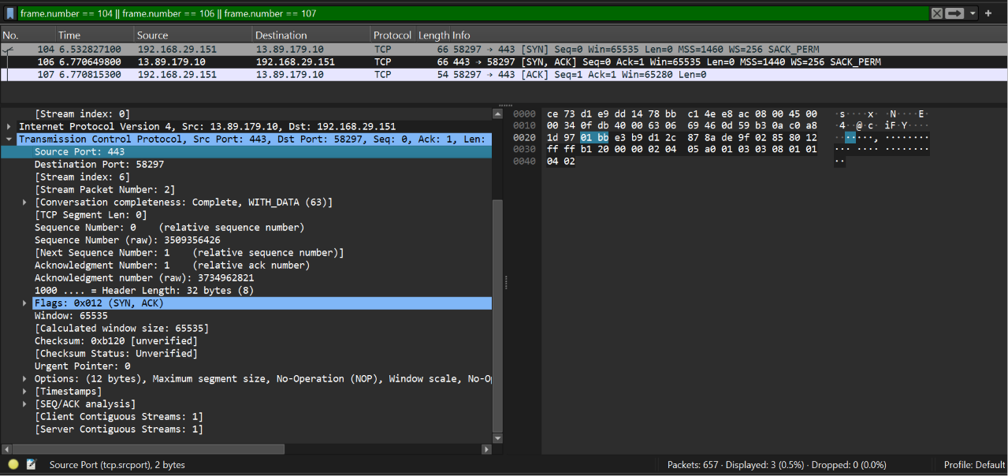
6.3 HTTP Traffic Analysis
HTTP traffic was captured by accessing http://neverssl.com.
The following packets were observed:
- HTTP GET request
- HTTP/1.1 200 OK response
Request Details:
- Method: GET
- Destination Port: 80
- Protocol: HTTP
Response Details:
- Status Code: 200 OK
- Content Type: text/html
Unlike HTTPS, HTTP traffic is transmitted in plaintext, allowing packet contents to be inspected directly.

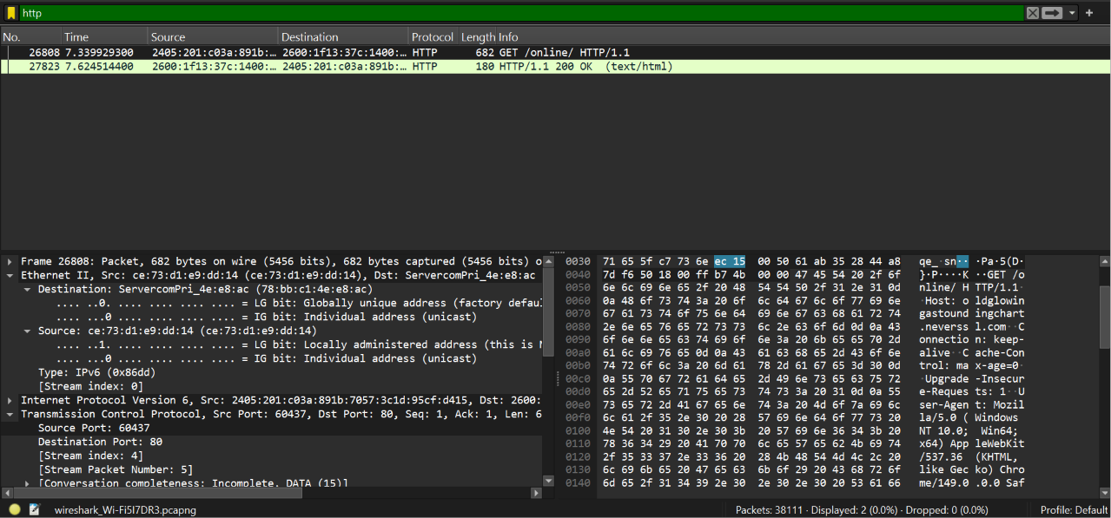

6.4 Packet Structure Analysis
Each packet consisted of multiple protocol layers:
- Frame Layer
- Ethernet Layer
- Internet Protocol (IP) Layer
- Transmission Control Protocol (TCP) Layer
- Application Layer (DNS or HTTP)
Key fields analyzed included:
- Source and destination MAC addresses
- Source and destination IP addresses
- Source and destination ports
- TCP sequence numbers
- TCP flags
- Application protocol data
7. Suspicious Traffic Analysis
The captured traffic was analyzed for anomalies using Wireshark filters.
Filters Used
- tcp.analysis.retransmission
- _malformed
Findings
- No malformed packets were detected.
- No significant retransmissions were observed.
- No suspicious or unexpected protocols were identified.
The captured traffic appeared consistent with normal web browsing activity.

8. Findings
- DNS successfully resolved domain names to network resources.
- TCP connections were established using the three-way handshake mechanism.
- HTTP requests and responses were captured and analyzed successfully.
- Packet headers provided valuable information about network communication.
- No indicators of malicious or abnormal activity were identified.

9. Conclusion
This task demonstrated the practical use of Wireshark for network traffic analysis. DNS queries, TCP handshakes, and HTTP communications were successfully captured and examined. The exercise improved understanding of protocol behavior, packet structure, and network communication fundamentals. No suspicious or malformed traffic was identified during the analysis.

